Flight Reservation (FR) Project

Software Requirements Specification

Table of Contents
Table of Contents II
Revision Log IV
1. Introduction 1
1.1 Purpose 1
1.2 Document Conventions 1
1.2.1 Abbreviations 1
1.3 Intended Audience 2
1.4 Project Scope 2
1.5 References 2
2. Overall Description 2
2.1 Product Features 2
2.1.1 Secured Login 3
2.1.2 Inserting new reservations 3
2.1.3 Confirmations 3
2.1.4 Updating existing reservations. 3
2.1.5 Removing existing reservations. 3
2.1.6 Search capabilities. 3
2.2 Known Bugs 3
2.3 Operating Environment 3
2.4 Assumptions and Dependencies 3
3. Requirements 4
3.1 Login 4
3.1.1 Description 4
3.1.2 Functional Requirements 4
3.2 Flight Reservation 6
3.2.1 Description 6
3.3 New Order Process 8
3.3.1 Description 8
3.3.2 Functional Requirements 8
3.3.3 Error Messages 8
3.3.4 Search for an Order 10
3.3.5 Report generation 11
3.3.6 Graph generation 12
3.3.7 Help Menu 12
3.3.8 About Menu 12

Introduction
A Product requirements document is used in product marketing to plan and execute new products.
A Software Requirements Specification is a complete description of the behavior of the system to be developed. It includes a set of use cases that describe all of the interactions that users will have with the software.
Use Cases are also known as Functional Requirements. In addition to use cases, the SRS also contains nonfunctional requirements.
The software requirements document is a written statement of what the software will do.
What the software does is directly perceived by its users. When the user performs some action, the software responds in a particular way.
Therefore you must agree on actions the users can perform and response they should expect. This common understanding is captured in the requirements document.

Purpose
This document contains the tests requirements for the Automation FR Project.
These software requirements were established by Dani Vainstein.
This SRS specifies to Mercury Flight Application Version 4a.

Intended Audience
Project team
Customers

Project Scope
This document defines at a functional level the business activities that are encompassed by the system and the rules that apply to them. It also encompasses some of the key high and low level technical requirements of the system.
It draws heavily on both proposed Framework and Business Rules and the Technical Architecture documents. The scope of the detailed analysis project phase specifies that this document will include.
- Classification of requirements according to their functional areas.
- A description of each process in the system, including their inputs, outputs, and data transformation rules.

References
- Databases
http://www.advancedqtp.com/knowladge-base/scripting-quicktest-professional/adodb/

Overall Description

Product Features

Secured Login
The system supports a secured login user/password.

Inserting new reservations
The application should be able to book new flight reservations for a future date requested, destinations and flight selections.

Confirmations
The application should be able to send fax confirmations to clients, about new, updates and cancelled flights.

Updating existing reservations.
The application should be able to update any data from an existing reservation.

Removing existing reservations.
The application should be able to cancel any existing reservation.

Search capabilities.
The application should support a searching mechanism by order number customer name and/or date of flight

Known Bugs
    - In the application database, table Flights, there is a field name Seats_Available. Usually the value is set to 250. I was trying to test if the reservations are limited and calculated. I ordered 400 tickets ( 40 iterations 10 tickets per-iteration ) and not get any error message.

Operating Environment
Windows operating system
Desktop Application

Assumptions and Dependencies
- You might need MS-Access to modify and view the flight application database.

Requirements
This part of the requirements document serves to present the "big picture" of the application. Here you lay out the objectives of the application.

Login

Description

The Login dialog, logs to the Flight Reservation application. A shortcut to the application demo can be found in
Start → Sample Applications → Flight.
The user must provide an Agent Name that must be at least 4 characters long and the Default Password is always "Mercury". Clicking the OK button will access the application if requested information is correct.
There should be option to register as a new Agent Name.
There should be a Forgot Password button and a forgot User Name button
The Login page should contain the Mercury tours Icon

Functional Requirements

Req0001
Req0001a - User activates the Flight Application executable file from installation directory plus "\samples\flight\app\flightxx.exe"
Req0001b - immediately afterwards the Dialog "Login" should be displayed.

Req0003
User press OK without entering any information.
Req0003a – Popup dialog is displayed.
Req0003b – Popup title "Flight Reservations"
Req0003c – message type: Exclamation
Req0003d – message text "please enter agent name"

Req0004
The agent name must be at least 4 characters long.
Req0004a - Popup dialog displayed: True.
Req0004b – Popup title: "Flight Reservations"
Req0004c – message type: Exclamation
Req0004d – message text "Agent name must be at least 4 characters long."

Req0005
The password must be at least 4 characters long.
Req0005a - Popup dialog is displayed.
Req0005b – Popup title "Flight Reservations"
Req0005c – message type: Exclamation.
Req0005d – message text: "Password must be at least 4 characters long"

Req0006
The field “Password” should not be empty.
Req0006a - Popup dialog is displayed.
Req0006b – Popup title "Flight Reservations"
Req0006c – message type: Critical
Req0006d – message text "Please enter password"

Req0007
Wrong “Password” field will trigger a critical popup message
Req0006a – Popup dialog is displayed.
Req0006b – Popup title "Flight Reservations"
Req0006c – message type: Critical
Req0006d – message text: "Incorrect password. Please try again"

Req0008
Pressing "Cancel" at any time should close the "Login" dialog after prompting for an confirmation message

Req0009
After 3 bad attempts to login (bad password) the application will trigger an information message and get closed.
Req0009a – Popup dialog is displayed.
Req0009b – Popup title "Flight Reservations"
Req0009c – message type: Exclamation
Req0009d – message text: "Login unsuccessful. Please try again later."
Req0009e – Application is closed.

Flight Reservation

Description
By inserting a valid and future date, and selecting a base and destination city, the user can choose a flight; order 1 to 20 tickets on 3 different classes. A client can receive a fax confirmation.
The user must provide a future valid Flight Date and must select a Fly From city and a Fly To city.
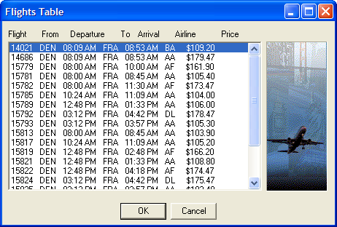
Figure 1 - Flights Table
The system will monitor from this point the price-per-ticket and the total amount to pay.
In addition the user can select 1 to 20 tickets and a flight class.
The information is inserted to a database, and a successful or failure message should be displayed in the transaction progress bar.
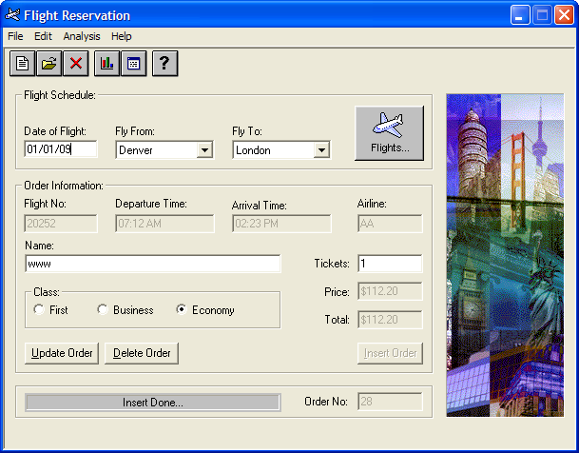
Figure 2 - Flights Reservation Window
In addition the user can get fax confirmation with an mandatory agent signature.
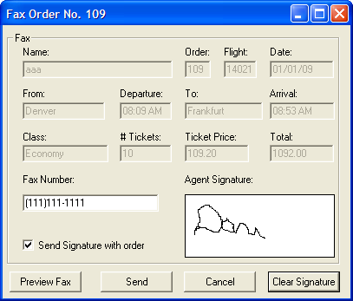
Figure 3 – Fax Order No. <n>

New Order Process

Description

Functional Requirements

Req0035
Only valid departures cities must be in list "Fly Form" and "Fly To"

Req0036
After selecting "Fly From" The "Fly To" field should not display the value selected in Fly from

Req0040
After typing a name, tickets or selecting a class the price of the ticket should be calculated appropriately.

Req0041
After pressing "Insert Order" – Application temporally disabled "Flight Reservation
After inserting a record the order number should be incremented automatically
While inserting a record there should be progress bar message to signify that the booking of the flight ticket is in progress

Req0042
After pressing "Send" progress bar message should be displayed as
Req0042a – Message "Dialing..."
Req0042b – Message "Connecting..."
Req0042c – Message "Sending Fax..."
Req0042d – "Fax Order No. <x>” should get incremented automatically
Req0042e – "Fax Sent Successfully…" message should be finally displayed
Req0042f – it should not send the Fax without duly signed in

Error Messages

Req0044
User types an invalid month.
Req0044a – Popup dialog is displayed.
Req0044b – Popup title: "Flight Reservations"
Req0044c – message type: Exclamation
Req0044d – message text: "Invalid month Entered.The month must be greater than 01 and less than 12."

Req0045
User types an invalid day
Req0045a – Popup dialog is displayed.
Req0045b – Popup title: "Flight Reservations"
Req0045c – message type: Exclamation
Req0045d – message text: "Invalid day Entered. The date should be valid for the given month."

Req0046
User type an invalid year (valid 2007-2038).
Req0046a – Popup dialog is displayed.
Req0046b – Popup title: "Flight Reservations"
Req0046c – message type: Exclamation
Req0046d – message text: "Invalid year Entered.
The year must be greater than 2007 and less than 2038.

Req0047
Valid dates are Today()+1, User type an old acceptable date.
Req0047a – Popup dialog is displayed.
Req0047b – Popup title: "Flight Reservations"
Req0047c – message type: Information
Req0047d – message text: "Valid flight dates are after <Today>"

Req0048
User select "Fly From" without "Date of Flight"
Req0048a – Popup dialog is displayed.
Req0048b – Popup title: "Flight Reservations"
Req0048c – message type: Information
Req0048d – message text: "Please enter a flight date"

Req0049
User select "Fly To" without "Fly From"
Req0049a – Popup dialog is displayed.
Req0049b – Popup title: "Flight Reservations"
Req0049c – message type: Information
Req0049d – message text: "Please enter a fly 'from' city."

Req0050
Valid number of tickets between 1 and 20, The user types an amount greater than 20.
Req0050a – Popup dialog is displayed.
Req0050b – Popup title: "Flight Reservations"
Req0050c – message type: Critical
Req0050d – message text: "Only ten tickets may be ordered at one time"

Search for an Order

There should be an open order window which would help us search for an particular customer order

The Search window should have an text box for an open search option where in the user can type any details of the order and the output will be a collection of details pertaining to the search

There should also be another button in open order known as “Advanced Search“ which would help the user search for a data with the following data :
- Cutomer Name
- Flight Date
- Order no

If data is not available then the message “Record not found “ should not be available.
Data extractable should be Agent specific .Only details of tickets booked by that particular Agent should be visible.The agent should not be able ot see tickets booked by other agents

Report generation

It should help generate the following reports:
- Details of agents and the number of tickets booked by them.
- Details of customers and the number of tickets booked by them.
- Details of flight number with the number of customer travelled till date
- Customer wise reports
- Agent wise reports
- Destination wise reports based on the Fly from anf Fly to inputs provided

Graph generation
Following graphs should be generated
- Number of tickets sold with respect to the dates
- Number of tickets sold by the agent Name
- Number of tickets sold and number of tickets cancelled
- Class wise tickets sold
- Destination wise tickets sold

Help Menu
The help menu should provide guidance to the users to navigate and perform the required actions
There should be a search facility
There should be a Tutorial
It should display the history of searches done
There should be helpline support details in every page of the help.Details should contain the email address and the phone numbers

About Menu
The about Menu window should contain the version details and the new enhancements of this version

Rewards for Agents
Rewards is an window which has the following options:
View point details – should display the total number of points accumulated by the agent name. It should also display details on the points earned for every booking
View catalogue : should display the catalogue and the agent should able to add it to the CART based on his eligibility of the points.If the agent name is not eligible ..it should display an error message accordingly
Redeem the points : This is a final confirmation window which contains the button redeem which the agent can click after filling in the proper delivery address details

Agents who have been booking tickets with mercury for the past 5 years and have booked more than 300 tickets till date will get an added bonus points of 1000
Agents who have been booking tickets with mercury for the past 2 years and have booked tickets more than 150 till date will receive an added bonus points of 500
Agents who have booked tickets more than 1000 will get and additional bonus points of 3000

Cancel Order
Cancel order is an option available on the home page
Agent can search for the record and then cancel the ticket
The Agent will be charged for the cancellation charges and accordingly the refunded amout will be calculated and get reflected in the total
The reward points will also be accordingly deduced

Update Order
If the record is an past record the update option should not be allowed.
For updating an order the editable fields allowed is only the date and the class
The Agent can increase the class of a customer but cannot decrease the class of a customer
Change can be allowed from economy → to business → to First

